**2020**

Godfrey Mabena

Project Management Report

10/16/2020

Project Management Report

 



**Assignment 2**

**Subject code: ISY34BT**

**Surname : Mabena**

**StudentNo: 216646797**

**Front Page**

**Initials : G Z**

1. **Mind mapping**

**Strengths**

* Increase students learning motivation
* Increase students’ academic achievement
* increases cooperation/collaboration ability
* increase students creativity
* increase ability to communicate

**Weakness**

* Can be time consuming
* Many instructors/teachers feel comfortable with traditional classroom
* Implementation of the project can be costly

SWOT ANALYSIS

**Opportunity**

* To try new ways of teaching and learning
* To increase productivity of learning and teaching
* To make the project to be the new normal

**Threat**

* The amount of equipment to be provided, so that the demand for electricity increases.
* Lack of student interest in the subject
* Lack of teachers interest in the new method of teaching

1. **Weighted Scoring Model**

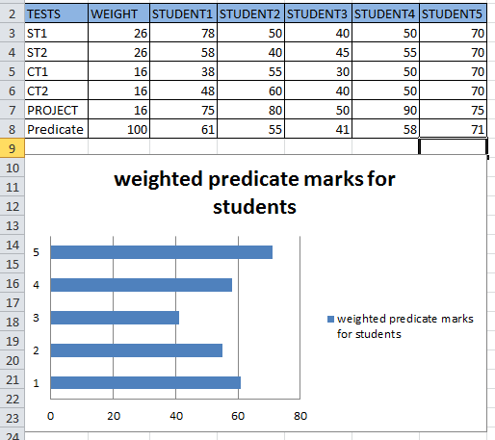

**Weighted Scoring model recommendations (5)**

**Student 1**

The student got 61% on his/her predicate mark and has managed to qualify for examination. For one to qualify for examination a student need 40% to be able to write exam, even if a student passed with a high mark the student will need a subminimum of 40% to pass the subject.

**Student 2**

This student qualified for exam with a predicate mark of 55, this is an average student and he/ she only needs 45% to obtain a final mark of 50% to pass the subject.

**Student 3**

This student also qualified for exam with a predicate mark of 41%. This particular student will need to get a final mark of 59% to pass the subject. I would recommend the student to put in a lot of effort to obtain a higher predicate mark. As he or she is in a difficult and stressful situation to pass the subject.

**Student 4**

This student qualified to write an exam with a predicate mark of 58%. This student will need to obtain a final mark of 42% to pass the subject. I would recommend the student to continue working hard and aim for a higher exam mark to obtain greater marks.

**Student 5**

This student is one of the hard working students who managed to qualify for exam with a predicate mark of 71%. This student needs to remember that there is a subminimum mark of 40% he/she only need 40% and above to pass the subject I would advise the student to keep working hard and not relax and try to aim for a distinction as he/she only needs 79% to get a distinction.

**Requirements Matrix**

The aim of the project is to develop a project to help students find jobs. On completion of the project the system should be able to collect information from the student and list available jobs that a student can apply for. For the system to be successful data has to be collected in order for the system to be functional. A student will enter Personal details on the application form, take a test to grade the student and search for a job that the student qualifies for.

|  |  |  |  |  |
| --- | --- | --- | --- | --- |
| Requirements No | Name | category | source | status |
| FR1 | Application form | form | Acas job application form templates | Complete. Application submitted to the database |
| FR2 | Take Test | test | Career aptitude tests | Complete. Provide result and place student |
| FR3 | Find job | search | CV library or careers24 | Complete. provide result and place student on waiting list |
| FR4 | State location | place | Google maps | Complete. List nearest available jobs for student |

**WBS (10)**

|  |
| --- |
| Level 1  JOB PORTAL |
| Level 2  Hire  Set up test  Data migration  Back-end development  USER INTERFACE |
| Level 3  Front-end design  Application development  HR team (approve application)  Develop list of required questions  Find Job  (search) |
| Level 4  Type  test  Years of experience  Educational level  Career level  Category  interview |

**Gantt Chart**

**PERT Chart (10)**

**Cost Estimation (5)**

**Earned Value Management (12)**

**Earned Value Management recommendations (6)**

**Recommendations (5)**